Voting App in action (URLs and screenshot)
Project Diagram 1
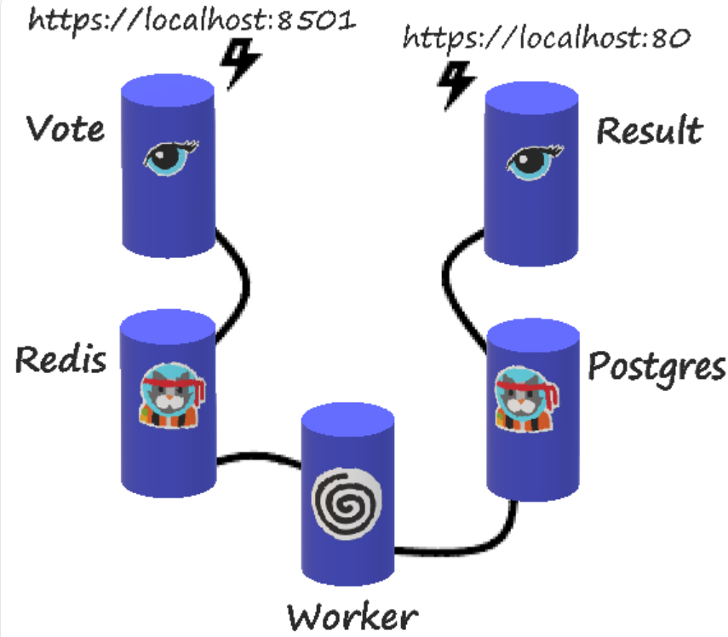

Project Diagram 2
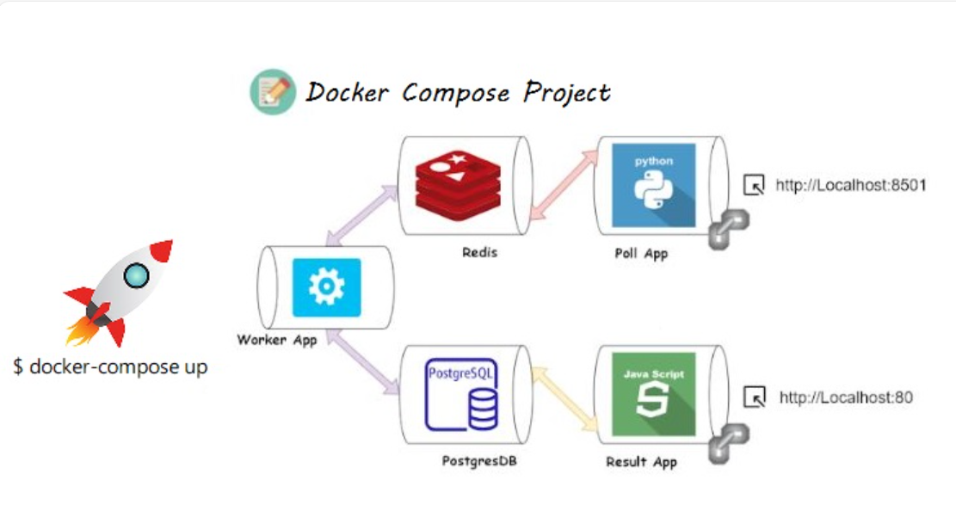

- Running the project
After execute command docker compose up it will create docker images and below containers as required.

Docker Images.
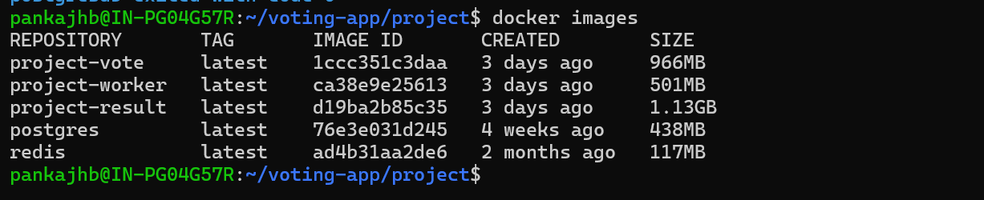

Docker Services.
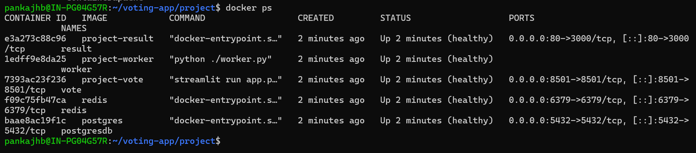
We see five different services were created like result, worker, vote, redis and postgress and also we attached all services to common docker network specified in docker compose file .

- Testing of application.

http://localhost:8501 for vote service were you we able to add your vote and http://localhost:80 were we able to see our result after refreshing the URL. Shown below

http://localhost:8501
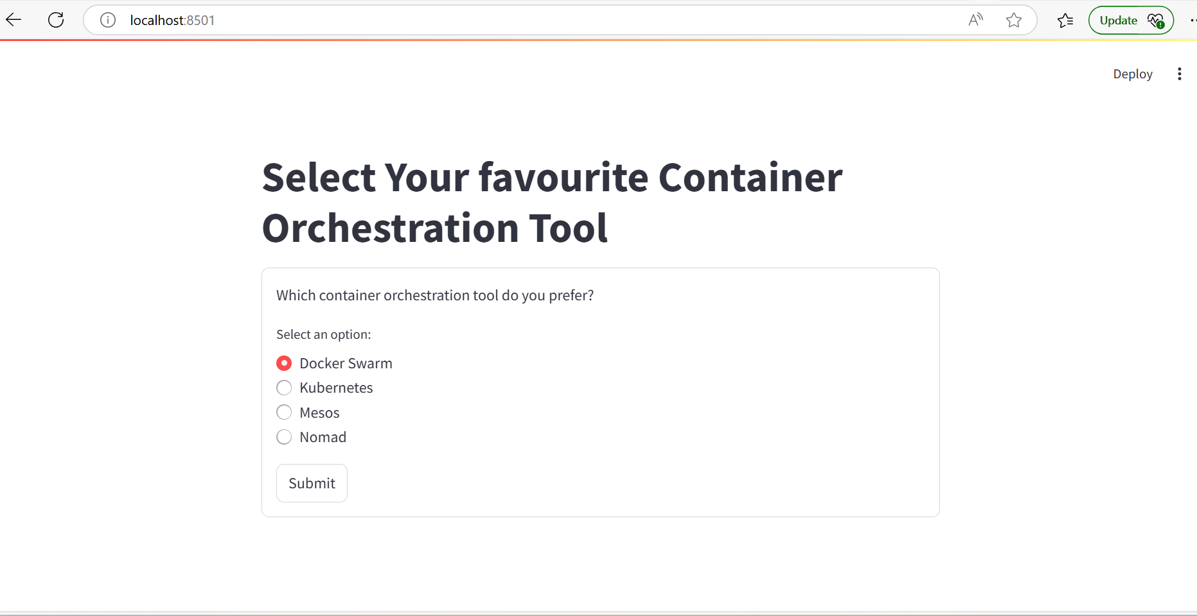

http://localhost:80
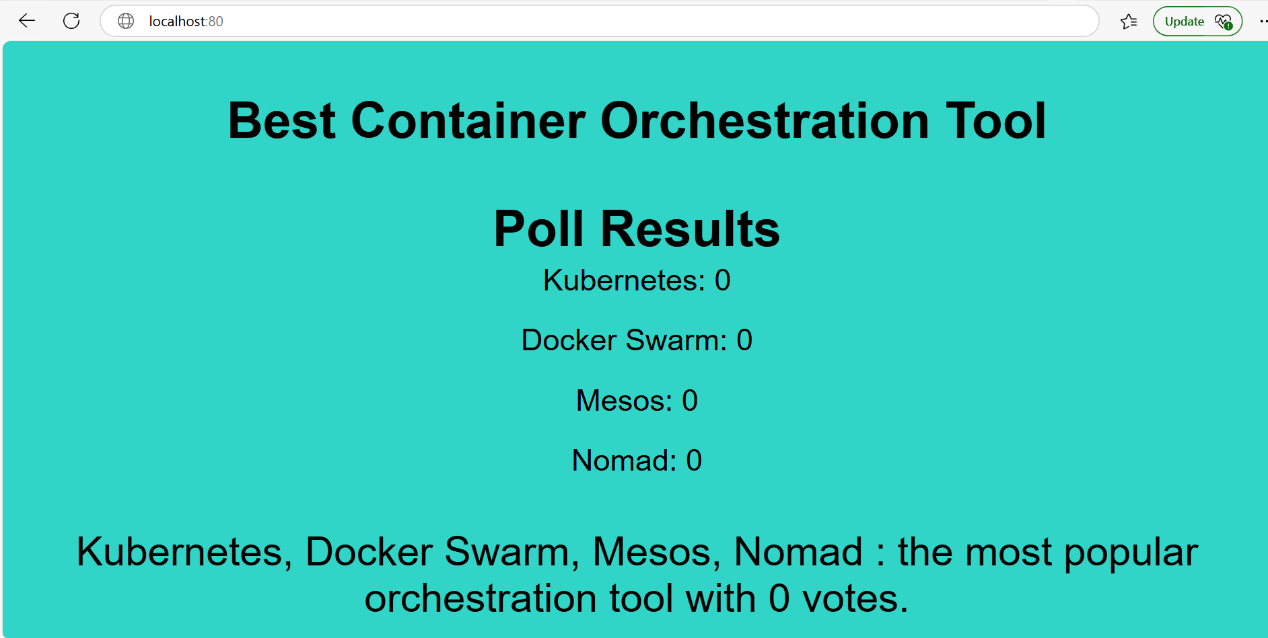

After adding vote on on of the famous tool you will see updated pole on result url shown below like I added vote on Docker Swarm it will update on result service

http://localhost:8501
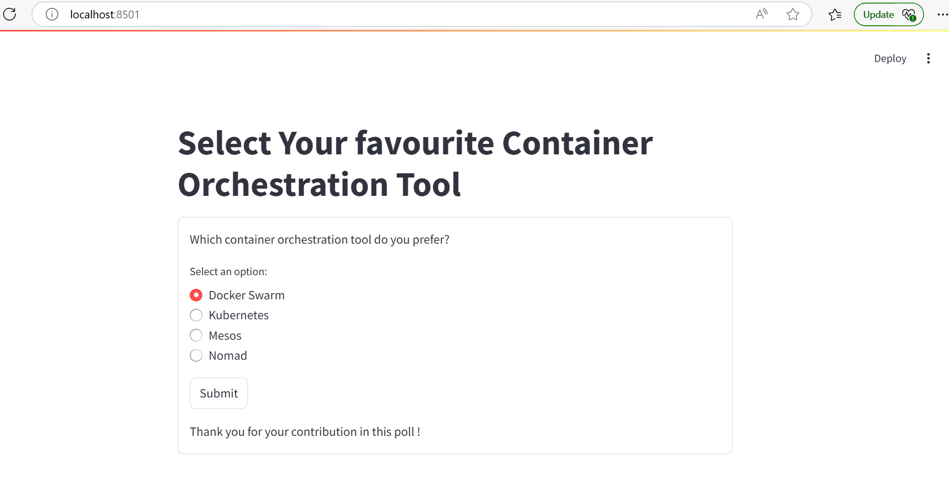
http://localhost:80
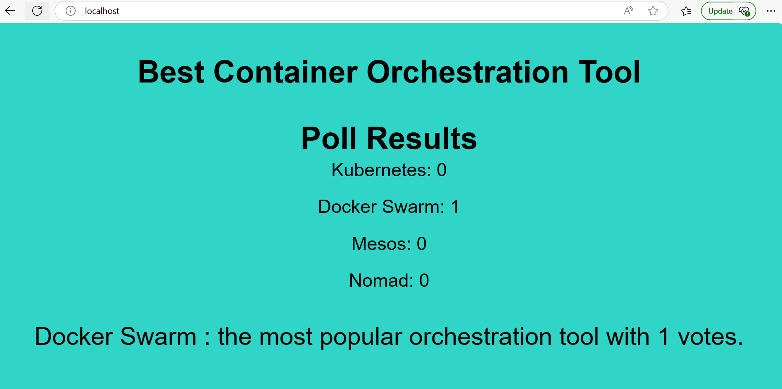

Also when I added vote on Kubernetes service, I will update on vote service shown below.
http://localhost:8501
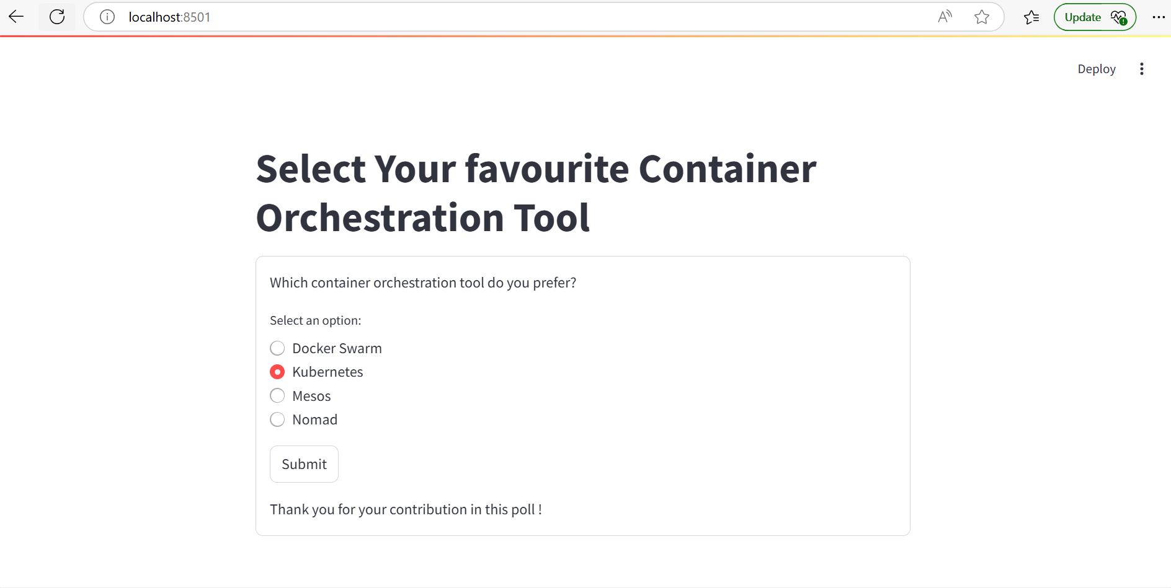
http://localhost:80
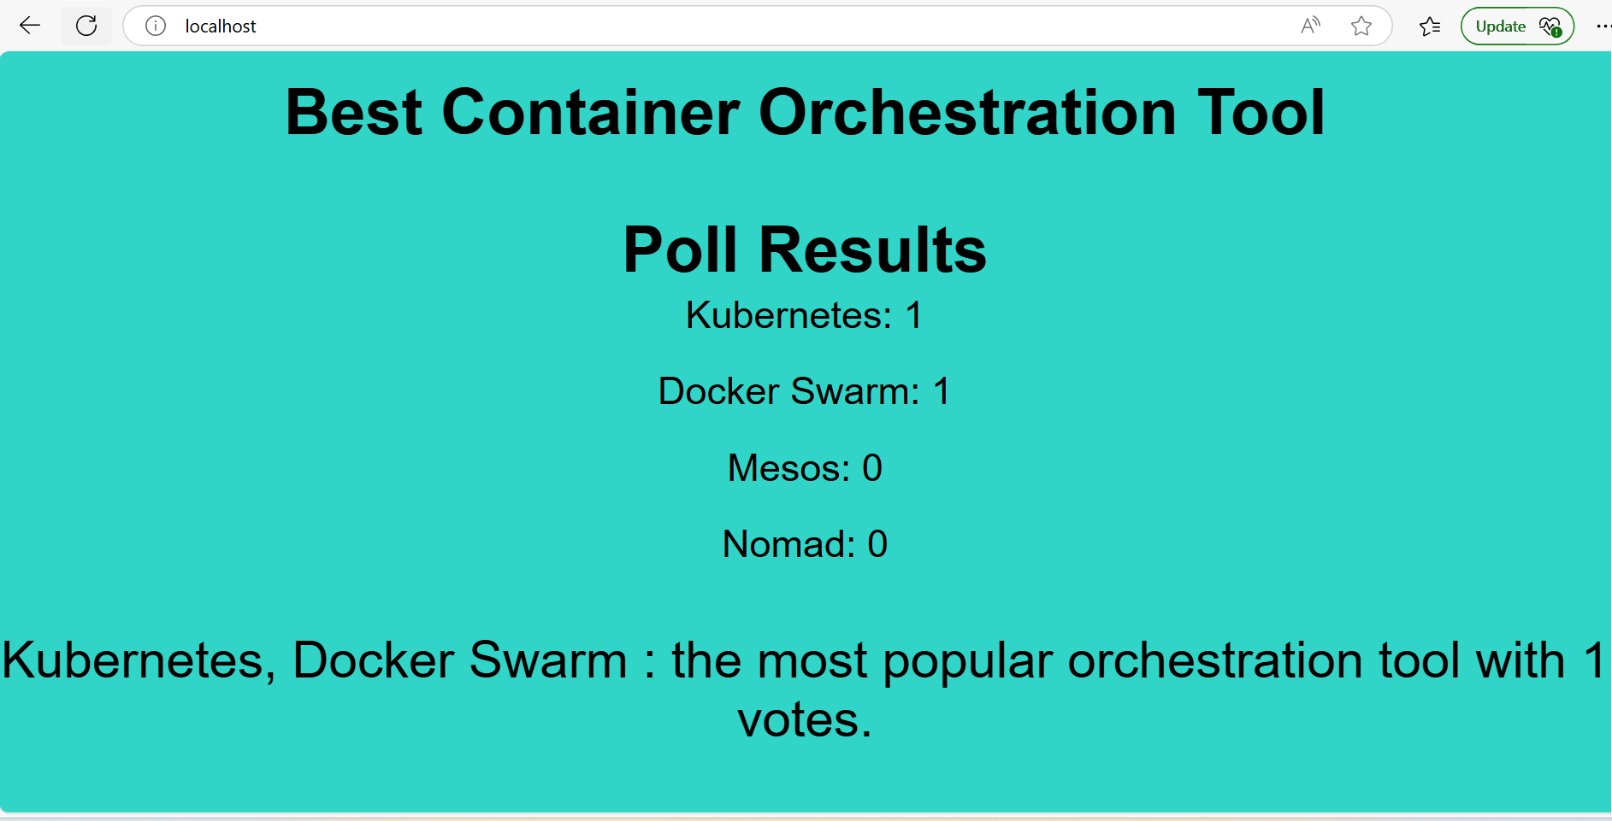

Now when I added three more vote on Kubernetes tool the vote service will update like shown below, it updated like Kubernetes is most famous tool.
http://localhost:8501 (vote service )
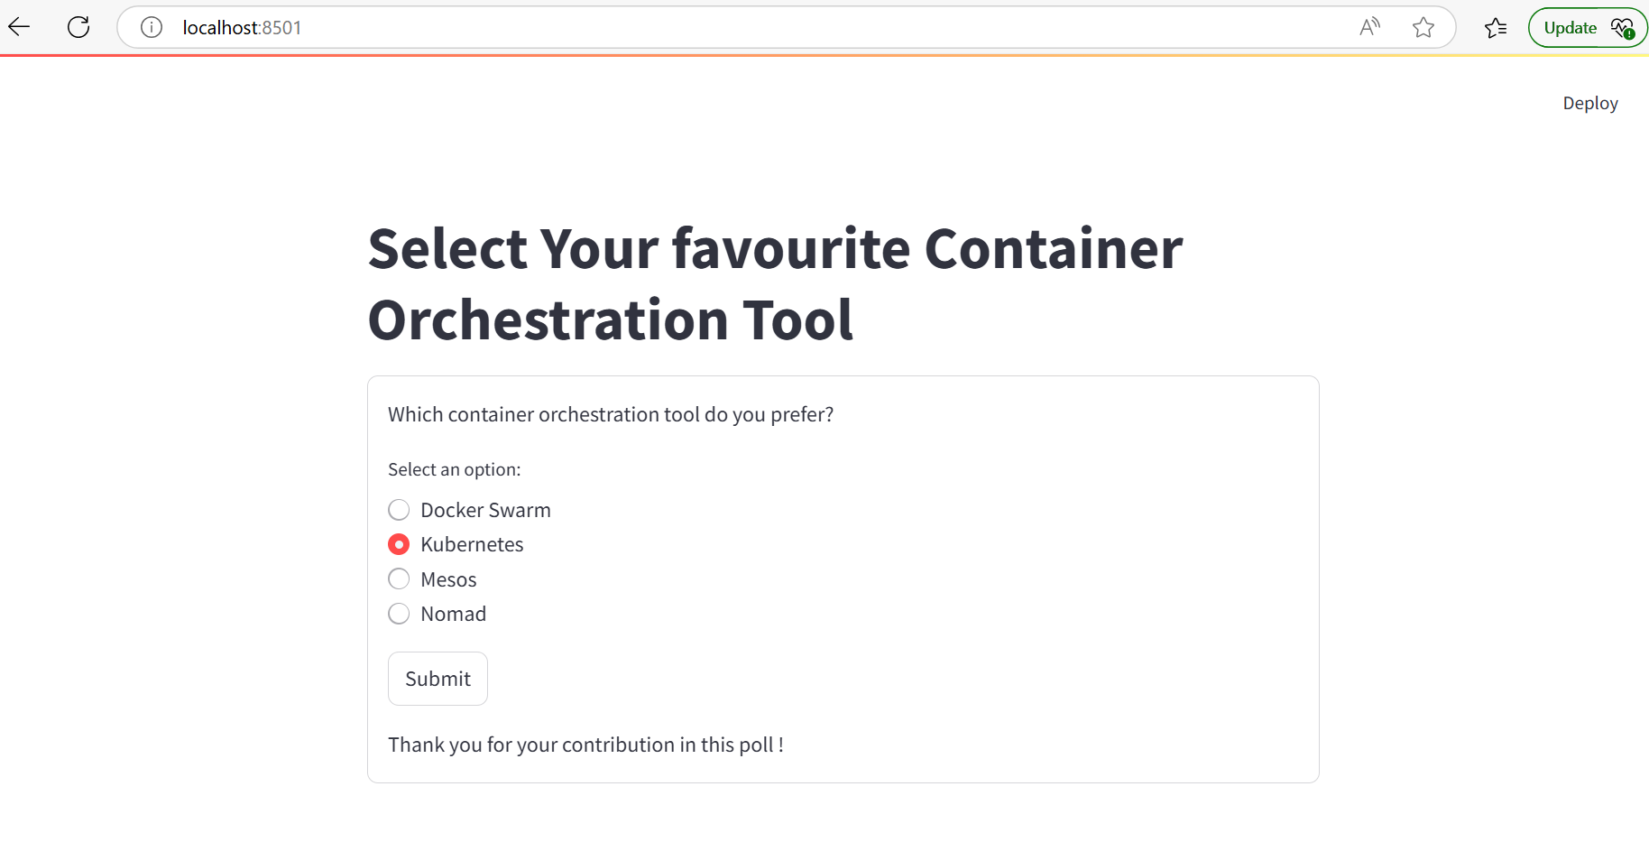
http://localhost:80 (result service)
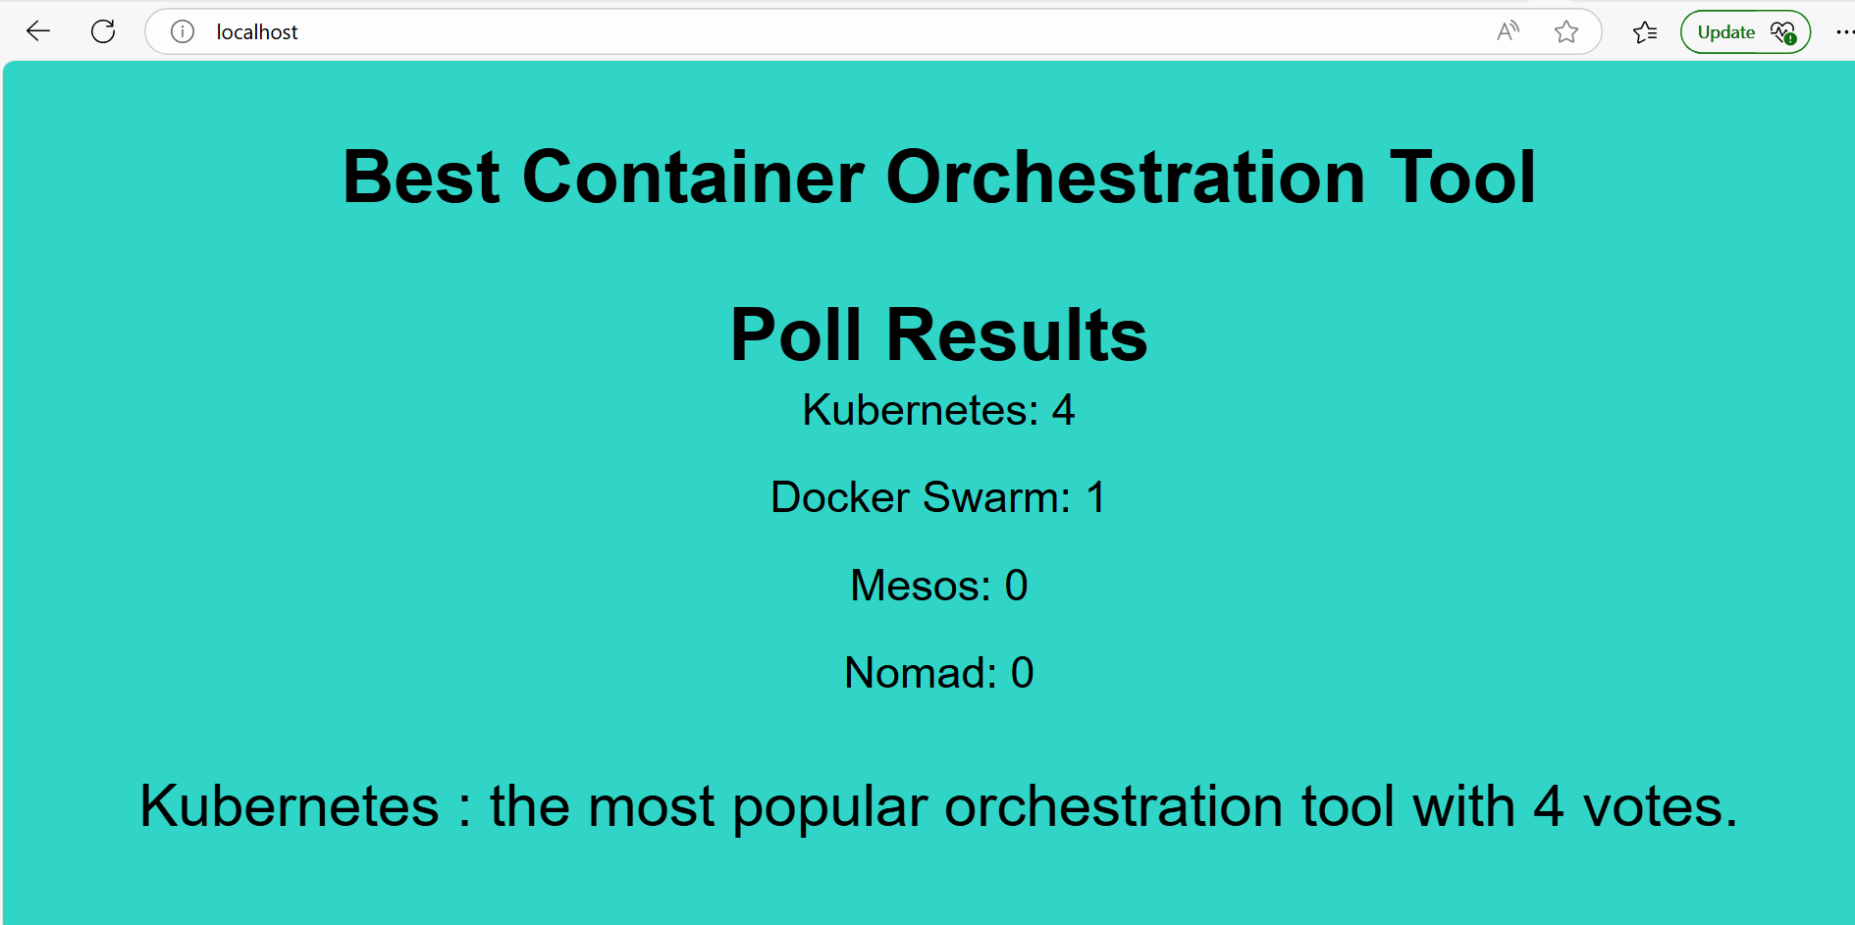

Git hub repo link :

